# Personal Information

Name: Don Vu

Student Number: s3398720

Student Email Address: [s3398720@student.rmit.edu.au](mailto:s3398720@student.rmit.edu.au)

Picture



# Background Information

Nationality: Vietnamese

Religion: Buddhist

Education to Date:

* Completed Year 12
* Completed Diploma of Financial Planning
* Completed IT Industry Certifications (ITIL, CCNA, Azure)

Languages spoken: Vietnamese, English

Fact:

I absolutely love fishing; I love the thrill of going on a boat out into the sea and cast my rod out and wait for a bite.

Although saying that, I struggle to set up my own rod and bait so I always tend to go with someone else that is more experience to help me out.

# Interest in IT

**• What is your interest in IT? When did your interest in IT start?**

I enjoy helping people with their problems. I also enjoy playing with technology and exploring their capabilities and limitations. So eventually I found myself in an IT job. After finishing year 12 I didn’t know which career to pursue. I initially went into Finance as a financial planner and ended up with a job as a financial planner for a company called National Sterling.

After about 6 months with this company, I realize this isn’t what I wanted to do for the rest of my life. I then went back into University and eventually made my way into a Service Desk role for a transport company. There I was exposed to the Service Desk, the technology and the excitement of confronting user issues and resolving it for them.

* **Was there a particular event or person that sparked your interest? Outline your IT experience (if any).**

I got into the that job without any prior IT knowledge or skills and I was mentored by my senior which to this is my inspiration. Not only was he knowledgeable but he was always calm and composed when there would be and outage or a core infrastructure failed. He taught me how to diagnose issues and how to handle them. I was working for that company for 2 years and eventually handling level 2 service desk jobs as well. After that due to family commitments, I was asking for a wage that the company could not offer and as a result I left the company to work for my current employer. Here I am an ICT Administrator for an enterprise business where I cover everything from networking, telephones, hardware/imaging, Citrix, VPN, SQL and many more.

**• Why did you choose to come to RMIT?**

I chose RMIT not only because of its reputable name, but also because of the flexibility it offers me studying part time whilst continue working. I find that the content RMIT supplies to its student can be used in the real working industry.

**• What do you expect to learn during your studies?**

I expect to be able to develop my foundations more solidly as well as learning new skills and knowledge to help raise the quality of my work. I also would like to develop more professional inter-personal skills such as interacting in teams, team work and working collaboratively.

# Ideal Job

**• The job advertisement itself. Include a link, and a snapshot of it (in case the link expires before the**

**assignment deadline).**

Seek Link: <https://www.seek.com.au/job/51797463>

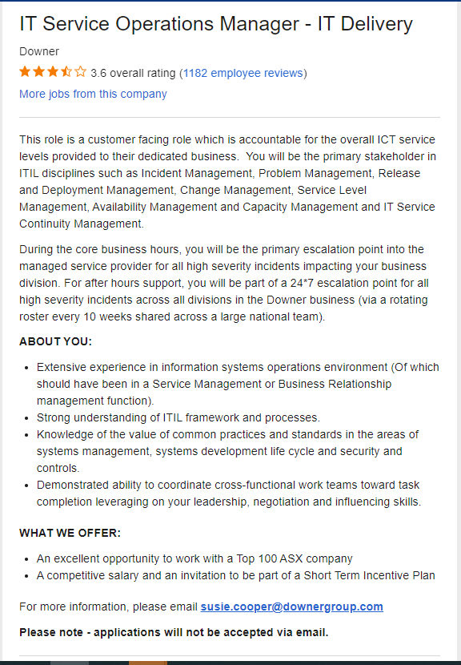

**• A description (in your own words) of the position, and particularly what makes this position appealing to you.**

This position will be in charge of all the ICT Service levels in the business. Not only will this be a role that all will escalate to for answer but there will be development and projects to manage and participate in. This role would be the person escalating severe outages to all managed service providers and will be on call 24*7.

Not only this company is a large company but it also offers a competitive salary but also the exposure of the position that manages and oversees all of the ICT operations in the business. The role requires to be able to manage different teams and groups to ensure the business can achieve its goals in the ICT

**• A description (in your own words) of the skills, qualifications and experience required for the position.**

This role requires a deep knowledge of information systems operation environment. This includes all the service management relationship with vendors and the infrastructure in which they look after.

This role requires the applicant to understand and practice ITIL which continuously find ways to improve and handle incidents in the business.

This role also requires the applicant to have a strong knowledge and experience in the areas of system management (housekeeping, updating, monitoring etc.…) system development life cycle (ensuring all the equipment in use is still under warranty and still supported.

This includes ensuring all software and images are patches and up to date to ensure that there are no security holes that can be exploited.

**• A description (in your own words) of the skills, qualifications and experience you currently have.**

Currently I have the skills to be an IT Administrator which includes and not limited to: Configuring Cisco switches, Networking, Hardware deployment, Cisco telephones, CISCO video equipment, VMWare, Citrix

The qualifications I hold are CCNA, ITIL, Azure Administrator.

**• A plan describing how you will obtain the skills, qualifications and experience required for the position, building on those you have now. This need not be greatly detailed, (and will probably change significantly over time anyway), but try to be as specific as you can.**

Firstly, I will need to continue accumulate more experience and explore to the industry. I need to complete and do more project work so that I am more exposed to all the technology and scenarios out there. At the same time, I will need to graduate from this bachelor’s course as well. In order to step into senior management position, it is generally expected that they have some sort of bachelor’s degree.

I will need to move around in the industry as well, most likely the next position will be an engineer position where I will be proposing and designing a solution for businesses. After a few years from that, I will be able to move to a different aspect of the industry which is more of consulting and leading for a business. A few years there I will be ready for accept jobs such as the one highlighted in this profile.

# Personal Profile

1. 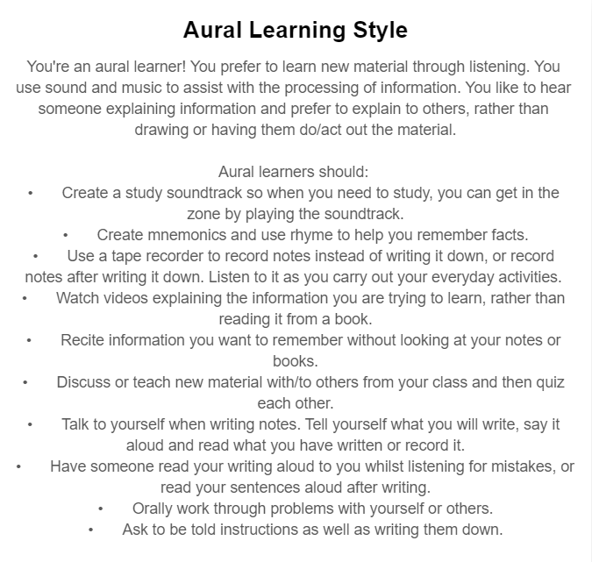

[https://www.matrix.edu.au](https://www.matrix.edu.au/quiz-whats-your-learning-style/)

1. What do the results of these tests mean for you?

Judging from the outcome of these result, I can say I can relate to them as some of them do highlight my personality for studying. It shows how I would always prefer to have someone dictate the information to me and have a visual aid to help me understand the information.

It shows how I like to logically draw out my materials and verbally recite the information as I write them down again. Overall, I can see that the result of this test is quite accurate in terms of how I study and how I retain information.

1. How do you think these results may influence your behavior in a team?

I think once I know the result and how it defines my learning methods, from now on I might be more inclined to do what the quiz results outlined. Even when it is not necessarily required, I would do draw it out or get someone to dictate it to me. It will become an issue as sometime time does not permit to go through the whole process to learn something. Sometimes the situation requires me to quickly learn something and apply it in the context that I need.

1. How should you take this into account when forming a team?

When forming a team, I should take into account to have someone that is self-driven to stand up and lead the team, that way I can perform better. I should also seek someone that can quickly understand the material and that can dictate the key points back to the group to ensure they understand the material and what to do.

1. 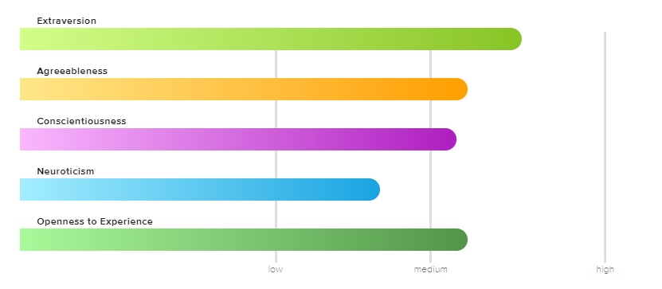

**Openness to Experience – Medium Characteristics**

You have a medium level of openness to experience. At times, you can be very creative, curious, and adventurous. At other times, you prefer routine. You are able to find a great balance between ideas and practicality.

You typically are a good problem-solver. When you are faced with a problem, you consider the tried-and true methods, but are also able to think outside the box. You are able to handle whatever life throws at you.

People who are moderate in openness to experience are well-suited for careers that balance creativity with stability – for example, journalism, photography, graphic design, or research.

**Extraversion – Medium Characteristics**

You have a medium level of extraversion. This means that at times, you get your energy from being around others; but at other times, you get your energy by being alone. Life is all about balance, and for you, it’s important to spend time alone and with others. You don’t mind being the center of attention at times, but you don’t seek out ways to be the center of attention either.

Because you have traits of both an introvert and extravert, you know when to speak up and when to stay silent. You are able to recognize the times when you need to speak up and be assertive, and can find the courage to have those difficult conversations when necessary.

Jobs for those who are moderately extraverted include those that allow building relationships with others, but also allow periods of time to work alone. The best jobs for these individuals include counseling, human resources, or being a director.

**Neuroticism – Low Characteristics**

You scored low in neuroticism. You are very emotionally stable. While others may experience emotions of extreme highs and extreme lows, you tend to stay somewhere in the middle. Others often describe you as calm, level-headed, and optimistic.

Because of your tendency to tend to “go with the flow” in life, you have a hard time understanding people who are extremely emotional or anxious. Those who score low in neuroticism have a difficult time understanding and spending time with people who are highly neurotic. You typically prefer spending time with people who are relaxed, like yourself.

In stressful situations, you are able to remain calm and think clearly. Others typically look to you for guidance when this occurs, and in many situations, you are a natural leader.

Because those who score low in neuroticism are so level-headed, they tend to do well in leadership roles. They typically make great managers and executives.

### Conscientiousness – Medium Characteristics

You scored medium on conscientiousness. At times, you are very driven and hard-working, but that doesn’t mean you don’t like to have fun! You are always able to set a comfortable balance between work and fun.

Your home isn’t spotless, but it is clean and organized. You don’t mind leaving a mess behind when you are in a hurry, but you make sure to clean it up later.

Your conscientious traits make you successful in your career – you are very reliable and hard-working. This, along with your friendly and relaxed personality, makes you a great employee to have. You finish what is expected of you, but aren’t too busy working to build relationships with your coworkers and supervisors.

### Agreeableness – Medium Characteristics

You scored medium in agreeableness. Others often describe you as friendly and helpful. You typically try to avoid conflict, but when a situation arises, you aren’t afraid to speak up. In group situations, you are able to find a comfortable balance between keeping everyone happy, but also speaking up and making the right decision.

You are a fairly generous person, and enjoy doing what you can to help others. In your free time, you may find yourself volunteering or helping friends and family with various projects. You believe helping others is important, but have not felt the need to devote your entire life to helping others. You do what you can to help, while making sure you are not being taken advantage of.

<https://my-personality-test.com/>

1. What do the results of these tests mean for you?

Overall, I think the results have reasonable grounds for their result as I can reflect on some of the result to be accurate. Majority of the category I have scored a medium besides from my emotional trait. It says I have a very stable emotional control and that I can always remain calm. That was a surprise to me as I would get anxious and nervous when the due date is near or when something unexpected has happened.

1. How do you think these results may influence your behavior in a team?

I think that since I’ve read this result, now I will be aware of what my personality is in a team environment and I will try to live up to it rather that just being myself. Before I knew these results, my actions and emotions were a result of what I felt was right. Now that there is a result and definition, I will feel more incline to achieve it.

1. How should you take this into account when forming a team?

I should definitely find people that have the same result as myself. This will enable the same ‘type’ of people to work together to achieve something greater. Another aspect of a team is to ensure all members are working together and can support each other to draw out the best in one n other.

1. 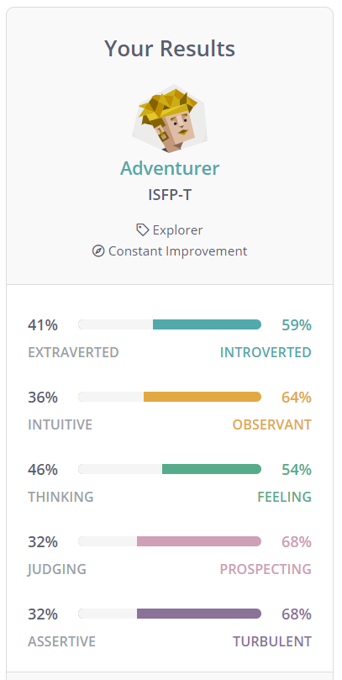 Myer-Briggs Quiz
2. What do the results of these tests mean for you?

This quiz doesn’t give me much to work on, normally other quizzes would have a breakdown of what the percentages mean. This only gives me a brief overview of the overall picture regarding my personality. The categorization sets me as an Adventurer, but does not break down what an Adventurer means.

1. How do you think these results may influence your behaviour in a team?

In this scenario I don’t think it will influence me a lot as I do not understand the results very much. It will overall most likely distract me whilst working in teams and make me doubt my actions as I don’t know what the results actually mean.

1. How should you take this into account when forming a team?

I don’t think this will affect me when forming teams, but it will affect my performance as it will constantly distract me as mentioned before.

# Project Idea

**Overview (100 words)**

The overview of this project will be creating an app to support something called micro lending. Micro lending are small loans that are issued by people rather than large corporate banks or credit unions. The purpose of this app is to connect the lender to the borrower. There will be two types of accounts in this app, a lender account and a borrower account. The app will allow the borrower to make an application whether it is an investment loan or a personal loan. Investment loan will allow the borrower to record a short clip to pitch their business nature and strategy, the personal loan will be a paragraph explaining why they need it and how they intend to pay for it. Once submitted, the lenders can see all applications and chose to ‘invest’ or ‘loan’ to the applicant of their choice.

**Motivation (100) words)**

This idea has risen due to the pandemic that is currently going on. The pandemic has increased the unemployment rate to 6.3% from what it originally was at the start of 2019, 5.0% (Welcome to the Labour Market Information Portal.. 2021)

The static shows that a 1.3% increase of unemployment has been recorded since the pandemic started, this means that were people that have lost their jobs and are struggling to get by. There needs to be another option for these people to seek some sort of financial assistance. This will allow these people a small chance in getting by through the tough economy.

**Description (500 words)**

The application will have a location tracker involved to determine the location of the borrower/lender. This will help filter out people from other countries trying to lend or borrow into Australia. It will also allow the lenders to selectively filter to either the whole country, state, or suburb to help local community.

Once the lender has identified whom to help or invest, they will have the option to fund the whole amount of the request or partial. If the whole request is funded, then the application will be removed from the list. If only it is partially funded then the remaining balance of the loan or application will remain in an open status for another person to fulfill.

As a reward for the lender, they will get 12.5% of the loan amount as their fees. The App will take 7.5% of the loan as the fee. Borrower’s fee will be 20% of their loan, no interest calculated. Loan term can be between 1 day to 3 months from receiving the money.

As a lender there is always a risk of the loan contract being a bad loan contract and won’t be able to recover their money. As a result, will impose a form of ‘insurance’ for the lender, if they borrower does not pay back the loan by the due date, the lender can opt to claim the insurance by paying the premium to get the original value of the money back. If they have lent $100 to a borrower, and the borrower does not pay back the loan then the lender can pay the premium (15% of the original loan amount) $15 to get their $100 back.

In terms for the borrower, to make an ‘investment’ loan they are required to submit a clip of their proposal for a business or project idea. The more detail and information they put into the application will increase

If they require a personal loan, they are required to fill in a questionnaire and write a small paragraph detailing why they need the loan and how they intend to pay for the loan or they will have an option to do a recording of a clip as well instead of writing the paragraph.

Once submitted all applications will be paced under ‘to be reviewed’ status to ensure that people do not put any offensive or abusive content on the system.

To ensure confidentiality, the borrower and lender will never need to speak, if they have any queries, it will be made to the app administrator and then the administrator will seek the answer and respond. There will be an option to report users as well, whether it be a lender or borrower.

Money payment will be done via Bank transfers. Once the lender commits to having a certain amount to lend, they can then select the borrower they intend to lend to. Once this is all decided, the bank will take the money from the lender and transfer it into the Apps bank account. Once the transaction is completed, the apps bank account will send the amount to the borrower’s account; this whole process can take up to 3 business days.

**Tools and Technologies (100) words)**

During the development stages, there are a few tools to help develop the app. For example, during the Wireframing stage, we will need tools such as Balsmiq, Moqups or Hotgloo to help us build the layout of the application.

We will need to have a functioning server located somewhere (i.e., Datacenter) and a database (SQL) to store the information and query the information. We will need to find a provider that will do all this and as well set up API for the application. This will need to be outsourced temporarily until the application grows then we can think of hiring inhouse solutionist to maintain and app.

Once the app is built, we can use TestFlight to test the app and once we are ready, we can publish it to Android Playstore. IOS we will need to submit it for review, once its been revied then Apple will release it to the public. (Bizness Apps. 2021)

**Skills Required (100 words)**

We would require someone that has experience in App development and API. This will form the foundation of the app and ensure that bugs are kept to the minimum.

Hardware we will require a database solution, normally SQL is the solution for many apps. To host this, we will require a physical server. Whether it be a local one or we need to hire this from a datacenter so that the physical components will be maintained. Another solution we could explore is use all cloud services. Using Azure we can hire a server, and build our infrastructure virtually.

The skills and hardware required for this project is rather simple and straight forward, there is a lot of professionals out there that are whether it be a service provider or a freelancer that will complete this project. Hardware wise, the accessibility is open and ready whenever the app is ready to be hosted. It is simple to set up and there is no large upfront cost as well. The service can be paid monthly.

**Outcome (100 words)**

If the project is successful, there will be a new platform for Mico-lending in Australia. This will be help thousands of Australians in times of need. This will also generate a small income stream for the app as being the host of the whole platform. Of course, once the app is released there will be tweaks and patches to be improved.

**Reference List**

Welcome to the Labour Market Information Portal.. 2021. Welcome to the Labour Market Information Portal.. [ONLINE] Available at: <https://lmip.gov.au/default.aspx?LMIP/LFR_SAFOUR/UnemploymentRateTimeSeries>. [Accessed 12 March 2021].

Bizness Apps. 2021. How To Make An App - Create An App In 12 Easy Steps. [ONLINE] Available at: <https://www.biznessapps.com/blog/how-to-build-a-mobile-app-in-12-easy-steps/>. [Accessed 15 March 2021].